IMPLEMENTATION LOGIC AND OUTPUT FORMAT

* NumOfItteration is assigned to 20 by default in order to generate 20 random values for Battery Parameters ‘temperature’ and ‘state_of_charge’ or else according to the value passed by the user
* In order to get proper ‘max’ and ‘min’ value for Battery Parameters ‘temperature’ and ‘state_of_charge’ calculated by the Receiver more than 5 random values are required(for accuracy purpose).

So before generating random values ‘NoOfItteration’ is checked if it’s greater than 5 or not.

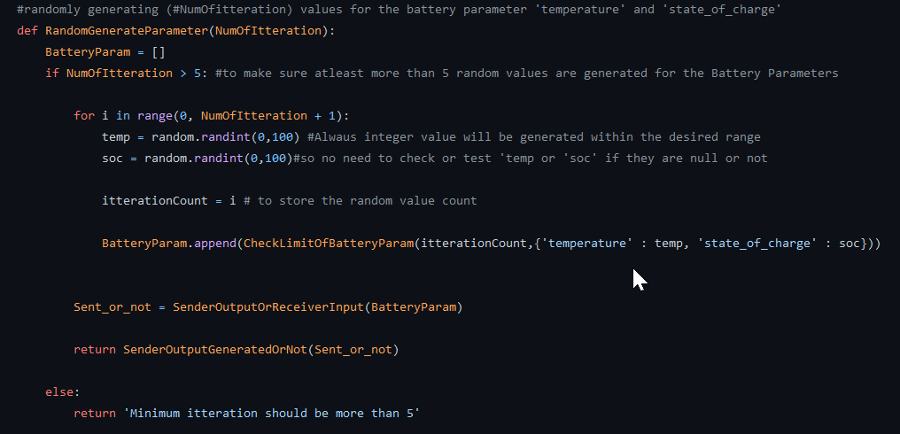

* Random integer value is generated for ‘temperate’ and ‘state_of_charge’ in the range 0 to 100 when ‘NoOfItteration’ > 5(as temp and soc will always be integer in the range ‘0’ to ‘100’ no need to check if it’s integer or not). Else it returns “Minimum Itteration should be more than 5”
* To keep track of the no. of battery parameters generated, str(itterationCount) is appended to the battery parameter name(e.g: itterationCount = 2 - > ‘temperature 2’ and ‘state_of_charge 2’ )
* Battery parameter values generated are then checked if they are within the limit or not. If not then ‘Check_limit’ is appended to the list along with ‘battery_parameter_name + str(itterationCount)’ and it’s value.

Else ‘Limit OK’ is appended to the list along with ‘battery_parameter_name+ str(itterationCount)’ and it’s value.

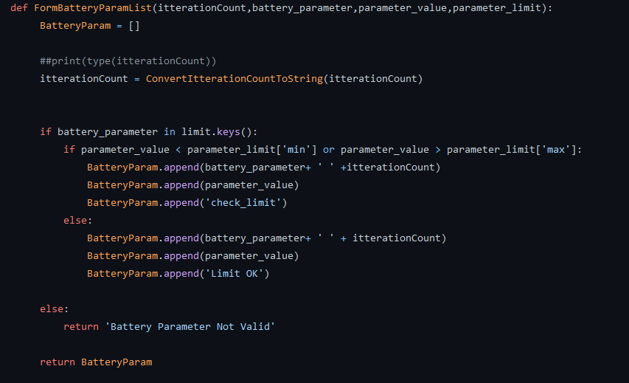

OUTPUT

At last a 3-D list will be printed with all the random values generated for the Battery Parameters and their corresponding check limit message

e.g: itterationCount = 6

0/P will be in the following format:

